Looking Ahead:
Jan 29 – SJL 8:30 Worship with Communion
SJL 9:30 Sunday School
SJL 9:30 Annual Meeting following 8:30 worship
CLC 10:30 Worship with Communion
Jan 30 – CLC 9:00 Quilting
SJL 9:00 Quilting
Feb 01 – SJL 4:30 – 6:00 Confirmation Class
Feb 02 – 8:30 Vicar at Birnamwood Elementary. For Reading Program
9:30 Vicar at Clover Leaf Terrace for service
(Volunteer’s needed to help with communion from SJL or CLC)
Feb 05 – SJL 8:30 Worship w/communion, Coffee Fellowship following
CLC 9:30 Bible Study
CLC 10:30 Worship
Feb 06 – CLC 9:00 Quilting
SJL 5:45 Fireman/EMT Soup Supper
Feb 07 – CLC 6:00 Council Meeting
Feb 08 – CLC 5:30 Confirmation Class
Feb 09 – SJL Welca Meeting at 2:00
Feb 09 – 15 Vicar Jennifer will be on vacation

St. John Members:
- Birnamwood Polka Days celebration - We will be holding the “Card Raffle” again this year and are looking for donations and volunteers to work the booth. Great Fundraiser.
- 3rd Annual Firemen’s/EMT Soup Supper – hosted by SJL on Monday, Feb. 6th at 5:45 pm. Please sign-up (back of church) to help with this event
- Coffee Fellowship – Sign up (back of church) to bring a snack/treat for the First Sunday of each month Coffee Fellowship.
- Ash Wednesday Soup Supper on Feb. 22nd following service (dine-in or Soup to Go). Look for the sign-up sheet.
- Welcome our new members: Jeremy & Shirley Thiex and Cody & Nicole Jayne Thiex. We are excited to have you in our church family.

Calvary Members:
- Thank you to our Women’s Group for providing the
hot beef and turkey sandwiches and buns for the Annual Meeting and to our council members for making the side dishes, desserts, and hosting the Luncheon.
- Congratulations and a big THANK YOU to our new council members: Melissa Ferg, second term council member Scot Peterson and to Julie Kubiaczyk for accepting the nomination to return to council after taking a 2-year break from council; but still remained very active in the life of the church. We appreciate
you and thank you for sharing your time and talents with us.

Fourth Sunday after Epiphany
January 29, 2023

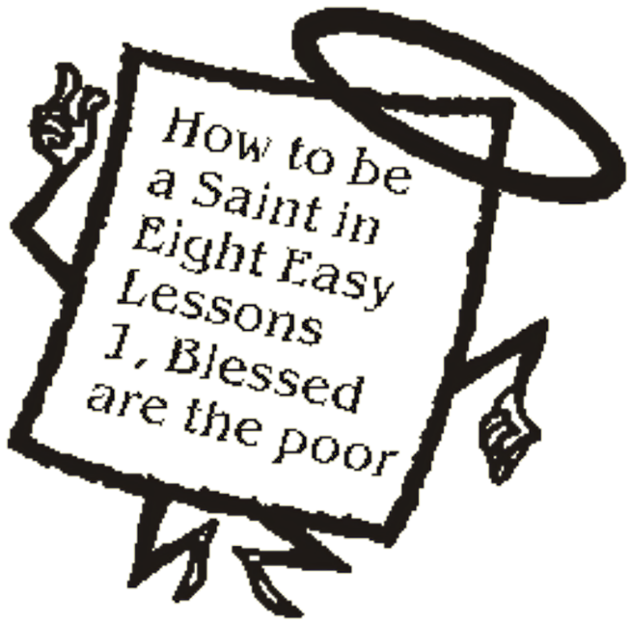
Jesus opens the Sermon on the Mount by naming those who are blessed in the reign of God.

KINDRED PARISH

Vicar Jennifer Sosinski 715-219-5489
Email: vicarjennifer@outlook.com

ST. JOHN LUTHERAN ELCA (8:30 a.m.)
W17680 Church Road – Birnamwood WI 54414
Phone: 715/449-2098
Email:stjohnlutheranchurch5444@gmail.com
SJL: Pianist Barb Nelson

CALVARY LUTHERAN CHURCH ELCA (10:30 a.m.)
310 S. Superior St. ~ Antigo WI 54409
Phone: 715/623-3102
Email: calvary.antigo@gmail.com
Organist: Joann Schmidt Song Leader: Peggy Benes
Lector: Alan Bahr

Fourth Sunday after Epiphany – January 29, 2023
Prelude
Call to worship
Welcome and announcements
SJL: Reception of New Members at St. John’s: Today we welcome – Jeremy & Shirley Thiex and Cody & Nicole Jayne Thiex into our St. John’s Family and as members of the Kindred Parish,

Confession and Forgiveness Back cover of hymnal
Hymn: “O God of Mercy, God of Light” #714
Greeting and Kyrie p.147
Canticle of Praise “This is the Feast” p.148

Prayer of the Day (in unison – see Celebrate Insert)

Readings: See Celebrate Insert
First Reading: Micah 6:1-8
R: The Word of the Lord C: Thanks be to God.
Responsive Reading: Psalm 15
Begin with refrain and repeat after the bold R
Second Reading: 1 Corinthians 1:18-31
R: The Word of the Lord C: Thanks be to God.

Gospel Acclamation (Please stand as you are able) p.151
“Alleluia. Lord, to whom shall we go? You have the words of eternal life. Alleluia.”

The holy Gospel according to Matthew 5:1-12
All: Glory to you, O Lord.
The Reading
The Gospel of the Lord. All: Praise to you, O Christ

The Sermon: Vicar Jennifer @ SJL
The Sermon: Rev. Betty Wyatt @ CLC

Hymn of the Day: “Jesus, the Very Thought of You” #754

Apostles’ Creed (inside back cover of hymnal)
The Prayers of Intercession (back of Celebrate Insert)
L: Merciful God. Response: Receive our prayer

The peace of the Lord be with you always. . . and also with you.
Share the peace with one another

MEAL
The Offering – The offering basket will be brought forward as we sing the
Doxology.

Praise God, from whom all blessings flow;
Praise God, all creatures here below;
Praise God, above ye heav’nly host;
Praise Father, Son, and Holy Ghost. Amen
Offertory Prayer
The Great Thanksgiving p.152
Holy, Holy, Holy p.153
The Lord’s Prayer (in unison) p.154
The congregation may be seated
The Invitation to Communion
The Sacrament is shared
(We have an open table for Communion. All who are baptized are welcome to receive the Lord’s Supper. Children who have not received their first communion and those not taking communion are invited to come forward for a blessing. We offer both wine and grape juice (center rings). Gluten-free wafers are available upon request).

Agnus Dei: “Lamb of God. . .” p.154
During communion . . .
HYMN: “Now We Join in Celebration” #462
HYMN: “Let Us Break Bread Together” #471

Prayer after Communion

Please be seated for the Blessing, Sending Hymn, and Dismissal.
The Blessing
Sending Hymn: “Just a Closer Walk with Thee” #697
The Dismissal Response: Thanks be to God.
Postlude

Kindred Parish Prayer Concerns:
Calvary: Samantha Smith, Lois Helms, Nancy Klemp, Don Guse, Ken Glover, Maverick Clark, David Schroeder, Theresa DeBroux, Patty Koeppel, Merna Schuman, Jan Cunningham, Amy DeBroux
St. John’s: Tom Opper, Joel Creydt, Cindy O., Bob G., Eric DeHart, Kristi Conzella, Ed Hilger, Danielle (Hegewald) Andrews, Andy Peterson
Prayers for members & friends serving in the military:
Greg, Tony, Joe, David, Isabel, and Daniel
Thank you to Rev. Betty Wyatt for leading us in worship today at Calvary Lutheran; allowing Vicar Jennifer the time to attend St. John’s Annual Meeting.

