ANNOUNCEMENTS
Calvary
- CONFIRMATION CLASS - Wednesday, May 18 (8th Graders Only)
Confirmation of 8th Grade Students will be on Sunday, May 22, 10:30 a.m.
- QUILTERS meet every Monday at 9:00 a.m. – noon
(all welcome)
- Next Council Meeting, June14, at 5:00 p.m.
- Still collecting for LWR: Towels, Soap and Toothbrushes

St. John’s
- Women’s Meeting at SJL: Thursday, May 19th at 2:00
- Birnamwood Polka Days – June 17 – 19 – SJL will be participating in this event. We need your help in selling Cards of Chance and also need prize donations. We have three large prizes that have been donated but would appreciate something to go with them – gift cards are a feat idea. Again, you can contact a council member for more information.
- Still collecting for LWR: Bath Size Bars of soap and combs (wide-tooth)
- GAS CARDS are still available for purchase to help to raise money for the parking lot, please see Andy or Jeremy if you are interested.

Kindred Parish
- Prayer List: Please help us keep our prayer concern lists up to date. If you have placed someone on the list please keep us informed of their status.
- Kindred Parish Joint Service - Wednesday, June 29, at SJL. Both parishes are invited to attend starting at 5:30 p.m. SJL will offer a picnic meal followed by 7:00 outdoor worship. This service will replace SJL’s Sunday Service on July 3. Calvary will still hold a 10:30 Sunday Worship on July 3rd at 10:30.
YOU ARE INVITED!
Last year’s joint service was great!

May 15, 2022
Fifth Sunday of Easter

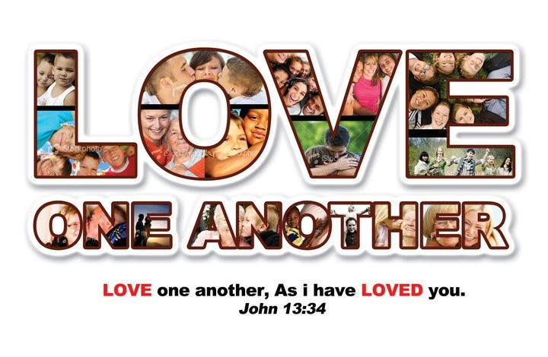

KINDRED PARISH

Vicar Jennifer Sosinski 715-219-5489
Email: vicarjennifer@outlook.com

ST. JOHN’S LUTHERAN (8:30 a.m.)
W17680 Church Road – Birnamwood WI 54414
St. John’s Phone number 715/449-2098
Email:stjohnlutheranchurch54414@gmail.co

CALVARY LUTHERAN CHURCH ELCA (10:30 a.m.)
310 S. Superior St. ~ Antigo WI 54409
Phone: 715/623-3102
Email: calvary.antigo@gmail.com

SJL: Pianist Barb Nelson
CLC: Pianist: Joann Schmidt Lector: Liz Dickman
Song Leader: Peggy Benes
Fifth Sunday of Easter – May 15, 2022
(*) indicates please stand as able
Prelude
Call to worship
Welcome and announcements

GATHERING
*Confession and Forgiveness Back cover of hymnal
*Hymn: “Beautiful Savior” #838
*Greeting and Kyrie p.147-148
*Canticle of Praise: “This is the Feast”. . . p.149
*Prayer of the Day (in unison – see Celebrate Insert)

WORD
Readings: as found in the Celebrate Insert
First Reading: Acts 11:1-18
R: The Word of the Lord C: Thanks be to God.
Responsive Reading: Psalm: 148
Begin with refrain and repeat after the bold R
Second Reading: Revelation 21:1-6
R: The Word of the Lord C: Thanks be to God.

*Gospel Acclamation p.151
“Alleluia Lord, to whom shall we go? You have the words of
eternal life. Alleluia.”

The holy Gospel according to St. John 13:31-35
Glory to you, O Lord.
The Reading
The Gospel of the Lord
Praise to you, O Christ

Children Sermon
Sermon: Vicar Jennifer Sosinski

Hymn: “Joyful, Joyful, We Adore Thee” #836

*Apostles’ Creed inside back cover of hymnal

*The Prayers of Intercession (back of Celebrate Insert)
R: . . .God , in your mercy Response: “hear our prayer”

*V: The peace of the Lord be with you always.
*C: and also with you
(remain in your pews – share the peace with one another).

MEAL
The Offering – the ushers will pass the offering baskets

The offering basket will be brought forward as we sing the Doxology.
Praise God, from whom all blessings flow;
Praise God, all creatures here below;
Praise God, above ye heav’nly host;
Praise Father, Son, and Holy Ghost. Amen

*Offertory Prayer

*The Great Thanksgiving p.152
*Holy, Holy, Holy p.153
*The Lord’s Prayer (in unison) p.154

The congregation may be seated
The Invitation to Communion
The Sacrament is shared
(We have an open table for Communion. All who are baptized are welcome to receive the Lord’s Supper. Children who have not received their first communion and those not taking communion are invited to come forward for a blessing. We offer both wine and grape juice (center rings). Gluten-free wafers are available upon request).

Agnus Dei: Lamb of God. . . p.154
During communion . . .
HYMN: “O Living Bread from Heaven” #542
“Just As I Am, without One Plea” #592

Prayer after Communion

Please be seated for the Blessing, Sending Hymn, and Dismissal.

The Blessing (Vicar Jennifer)
Sending Hymn: “How Great Thou Art” #856
(Candles are extinguished during last verse of hymn)
The Dismissal. Response: Thanks be to God.
Postlude
Kindred Parish Prayer Concerns:
(Calvary) Audrey Nelson, Nancy Klemp, Jack Grabowsky, Lucille VanOoyen, Jenny Olsen, Patty Koeppel, Nancy Tews, Scott Johnson, Merna Schuman, Tommy Erlandson, Jan Cunningham, Amy DeBroux, Dennis Prigge.

(St. John’s) Cindy O., Bob G., Eric DeHart, Ron Uttecht, Michelle Buss, Kristie Corazalla, Ed Hilger, Danielle (Hebewald) Andrews, Andy Peterson.

Prayers for members & friends serving in the military:
Tony, Joe, David, and Isabell.

