Calvary Lutheran Church ELCA
310 S. Superior St.
Antigo WI 54409
715/623-3102
Address Service Requested

CALVARY CURRENTS

Calvary Lutheran Church
310 S. Superior St.
Antigo, WI 54409

Church Phone 715/623-3102
In case of emergency pastoral care: Rev. Betty Wyatt 715-219-8132 / Deacon Pam Werth 715-219-6363
Adm. Asst.: Lynda Eschmann Cell: 715-216-0342 Home:715-623-7938
Custodian: Richard Tews: 715/623-3522

Your Church Council for 2019:
Dan Young: (President) - 715-253-3938
Dale Waterhouse: (Vice President) – 715-350-9901
Joann Schmidt: (Treasurer) - 715-216-7106
Angie Close: 715-610-7118
Linda Grall: 715-219-3912
Julie Kubiaczyk: 715-627-4077
Craig Nelson: 715-623-4154

 | January 2020
Sun | Mon | Tue | Wed | Thu | Fri | Sat
 |  |  | 1 | 2  6:00 PM Worship with  Holy Communion  Pastor Betty Wyatt | 3 | 4
5  9:00 AM Text Study  With Glen Gildemeister  10:00 AM Worship  Leader: Edd Hill | 6  9:00 AM Quilting | 7  6:00 PM Calvary Church Council  6:00 PM St. John’s  Church Council | 8  3:30 PM Confirmation  Class  5:30 Calvary’s Kids | 9  6:00 PM Worship with  Holy Communion  Pastor Betty Wyatt | 10 | 11  10:00 AM Grief Support  Fellowship Hall
12  10:00 AM Worship with Holy Communion  Pastor Bruce Beyer  Reception of New Members  Donut Sunday | 13  9:00 AM Quilting | 14 | 15  3:30 PM Confirmation  Class  5:30 Calvary’s Kids | 16  6:00 PM Worship with  Holy Communion  Pastor Betty Wyatt | 17 | 18
19  10:00 AM Worship with Holy Communion  Pastor Bruce Beyer  11:00 AM St. John’s  Corporation Meeting | 20  9:00 AM Quilting | 21 | 22  3:30 PM Confirmation  Class  5:30 Calvary’s Kids | 23  6:00 PM Worship with  Holy Communion  Pastor Betty Wyatt | 24 | 25
26  10:00 AM Worship  Leader: Edd Hill  11:00 AM Calvary’s  Annual Meeting | 27  9:00 AM Quilting | 28 | 29  3:30 PM Confirmation  Class  5:30 Calvary’s Kids | 30  6:00 PM Worship with  Holy Communion  Pastor Betty Wyatt | 31

Council Person in Charge: Julie Kubiaczyk, Ministry of Social Concerns
Thursday Altar Guild: Jan Young, Rachel Noskowiak, Karen Traut, Joann Schmidt
Sunday Altar Guild Jan: Connie Peterka
Thursday Service Ushers & Greeters: Loren & Wilma Lucia

Sunday Ushers & Greeters Sunday Lectors Sunday Communion Assistants
Jan 05 Dick Strasser & Dale Peterson 05 Dick Strasser 05 No Communion
Jan 12 Tim Grall & Ted Clark 12 Dale Waterhouse 12 Connie Peterka
Jan 19 Craig Nelson& Larry Poltrock 19 Kathy Stockhaus 19 Kathy Stockhaus
Jan 26 Dale Waterhouse & Dan Young 26 Angie Close 26 No Communion

Annual Meeting(s)

At first glance, it may appear that the January, 2020, calendar has a duplicate entry for the annual meeting! Both January 19th and January 26th have a very similar notation.

The Calvary annual meeting is on the 26th, and the usual business will be conducted.

Members of St John’s still have an annual meeting, too, which will be on the 19th. While St. John’s is no longer a Lutheran congregation, it is still recognized by the State of Wisconsin as a living corporation. As a corporation, it can still conduct financial business, still has a council, and appropriate officers. There will be an election for two open council positions, review and approval of minutes and various financial reports on the agenda. The meeting will be held at Calvary since a good number of St John’s members have begun to attend, and it is a convenient place to meet.
- Alan Bahr
Council President, St. John’s Lutheran
Happy
January Birthday
03 Kathleen Runyon
04 Hannah LeVeque
06 Loren Lucia
Daniel Stockhaus
10 Barry Stockhaus
11 Jodi Gass
12 Sally Zwicky
14 Karen Traut
17 Todd Langesth
Earl Opheim
18 Jason Hilger
21 John LeVeque
22 Donald Dolezal
25 Scott Bolson
Lynn Wheeler
27 Judith Byrd
28 Stacy Kautza
Ariane Zimmerman
29 Bette Hansen-Clay
30 Emberli Depies
Erik Nelson

God has blessed us with many gifts and talents. Our church council currently has five openings and would appreciate it if you would prayerfully consider being on council. We are proposing one year terms on council. If interested please contact Angie Close at aclose@co.langlande.wi.us or text/call 715-610-7118.

_____________________________________________________
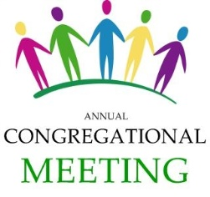
Mark Your Calendar – Learn what is happening!
Our Annual Meeting will be held on
January 26, 2020, immediately following our worship service. Please plan on attending. A light
lunch will be served.

Some congregations are blessed with one pastor or worship leader – Calvary has been blessed with many over the past year. We thank them for all they have done for Calvary and continue to do.
Pastor Natalie Bassett (Wausau/Hospice Chaplain)
Pastor Bruce Beyer (Weston/Retired)
Pastor Nicole Behnke-Welke (Shawano/Hospice Chaplain)
Pastor Jeff Martinson (Wausau/visitation pastor, St. Andrew)
Pastor Tryhine Schruba (Wausau/Retired)
Pastor Bill Schruba (Wausau/Retired)
Pastor Betty Wyatt (Aniwa/St. Paul’s Lutheran)
Deacon Pam Werth (Pearson/Arbutus Lutheran)
Lay Ministers: Edd Hill
Glen Gildemeister
Dale Waterhouse
Joann Schmidt

It has been exciting to experience the many different styles and gifts that each of you bring.
Thank you to all for your for sharing your gifts and talents with us.

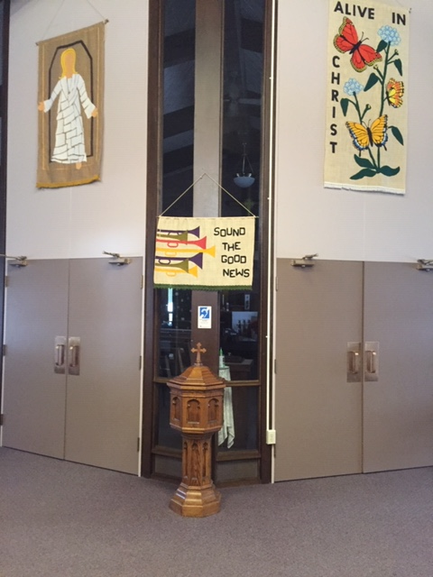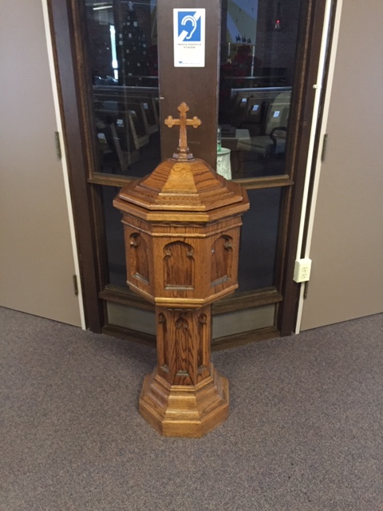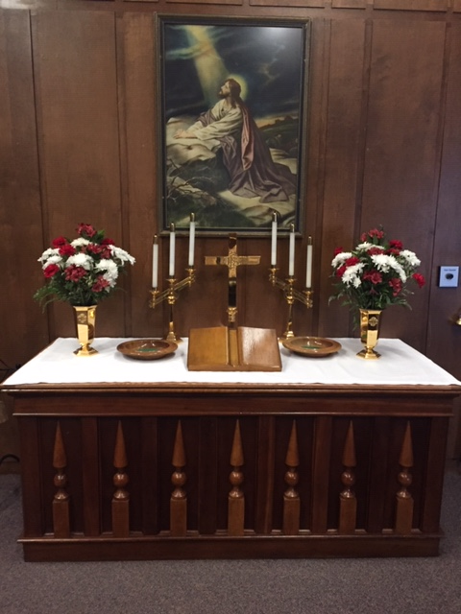

A Blending. . .

. . . since the dissolving of St. John’s in Polar we have been blessed with the addition to our church of many of their treasured items from the baptismal fount to the altar.
You will see some of their banners hanging above the doors as you enter the sanctuary, between the doors is the beautiful baptismal font, in the narthex is the altar and picture that hangs above it. You will see several additions throughout Calvary including new members. Please welcome them as they join our church family. New members will be received on January 12 during Sunday Worship. We welcome you with open arms.
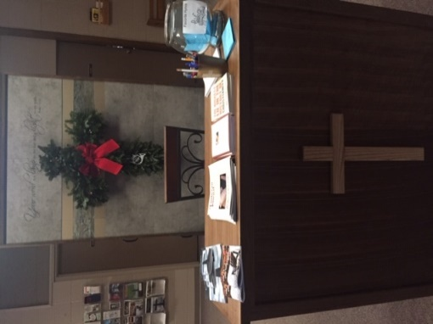
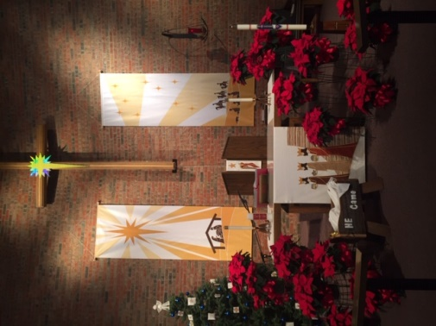
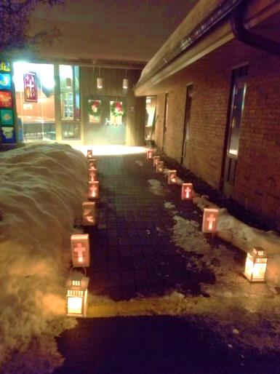
________________________________________________________________________________

Christmas Eve Service was wonderful and we have a lot of people to thank for sharing their time and talents. Deacon Pam Werth provided a delightful and meaningful sermon based on “A Charlie Brown Christmas” (we will now look at Linus’ blanket in a different light). As Linus says, “I never thought it was such a bad little tree. It’s not bad at all really. Maybe it just needs a little love”. Rich Tews and Ron Peterka decorated the sanctuary, Barry Stockhaus and family provided and cared for the beautiful luminaries that lined the entrance ways to the church. The Women of Calvary donated the wreaths for the church doors. . .And Calvary members graced the sanctuary with poinsettias in memory or honor of their loved ones. Thank you to our ushers, Craig Nelson & Larry Poltrock and our Acolyte Brayden Vielbaum.

Thank you to Pastor Betty Wyatt from St. Paul’s in Aniwa for sharing the following message with us.

Pastor’s Corner Jan Feb 2020

Psalm 121 – I will lift mine eyes to the hills. Where does my help come from? My help comes from the LORD, the Maker of heaven and earth. He will watch over your coming and going both now and for evermore.

By the time you receive this newsletter our days will once more be having more day light each day. Maybe you have way too much to do and hibernating like a bear seems very pleasing right now. I guess that is why coffee was made and of yes, chocolate candy bars – anything for a caffeine kick to start or restart energy. I noticed that if I eat something early in that day that is sweetened, like sugar on my cereal, I crave it all day long and want more and more to satisfy the craving. That isn’t diet controlling at all is it? Bring on the natural stuff to feel natural it seems. I found the following reading on Facebook the other day and wondered if you can find yourself in any of the lines. I sure do!

When God said “No”
I asked God to take away my habit. God said, “No, it’s for me to give it up.”
I asked God to make my handicapped child whole. God said, “No, his spirit is whole his body is only temporary.”
I asked God to grant me patience. God said, “No. Patience is the byproduct of tribulation. It isn’t granted.”
I asked God to give me happiness. God said, “No. I give you blessings. Happiness is up to you.”
I asked God to spare me pain. And God said, “No. Suffering draws you closer to me.”
I asked God to make my spirit grow. And God said, “No, but I will prune you to make you fruitful.”
I asked God for all things that I might enjoy life. God said, “No. I give you life, so that you may enjoy all things.”
I asked God to help me love others as much as he loves me. And God said, “Ahhhhh, finally you have the idea.”

We many times want to get rid of the pain in our lives for it’s a heavy load – not meant for us to carry alone however. I know God walked with me many times in the pain of grief that did not want to go away. I wrote my prayers to God about it to have someone to hear me out no matter how much I needed to discuss it… without people just thinking, “It’s been over a year already she should be getting on with things.” One time I told an instructor that I was glad that the class would teach me how to get rid of pain that joy could become my new reality. The instructor taught me that the pain was a part of my story that helped form me. Yes, empathy, listening in silence, sitting by someone – just being there, for I’ve had to learn I can’t fix people, that it’s God’s doing.

We live in a world of bitterness, with grandiose expectations in thinking things should be perfect. We need kindness and forgiveness woven into a new reality for the months ahead. Forgiveness – practicing forgiveness as humbling as it seems, is healing. That’s a lesson I continue to work on as well as accepting people as they are. Some say it all starts with forgiving and loving the self in order to forgive and love others. Study with me the art of forgiveness as 2020 sneaks around the corner into a new year. It is faith’s journey. It’s part of loving others as God loves us.

Shalom – may all be well within and about you.

Pastor Betty

Help Needed
We will be setting the schedules
for Ushering, Altar Guild, Lectors, and Communion Assistants. If you are currently on the list and need to be removed please let Lynda know as soon as possible, if we don’t hear from you we will continue to place you on the schedule.
If you are not already on any of the schedules and would like to serve your church in any of these areas please let us know.
If you have questions about any of these ways to help we will be glad to assist you.
New members are invited and encouraged to participate as you feel comfortable.

Donut Sunday
The Second Sunday of each month is “Donut Sunday”. Council members and their committee members provide the coffee and treats following service. We invite you to participate in this time of fellowship as we gather in Fellowship Hall following worship.
Text Study
The First Sunday of each month

We are pleased to have Glen Gildemeister lead us in a Lectionary Bible Study. The study is based on the Lectionary (lessons) for that Sunday.
Glen is former Director of the Regional History Center at Northern Illinois University and the University Archivist. He presents an interesting and informative study and we are so pleased that he is willing to share his time and talents with us.
The Study is held prior to Sunday Worship from 9:00 Am to 9:45.

Note: He also makes wonderful baked goods! So come enjoy a cup of coffee, fresh bakery, fellowship, and dig a little deeper into the lessons for that Sunday morning. It will enhance your worship experience!
Offering Envelopes
Your 2020 Offering Envelopes
can be found on the table in the narthex near the south door entrance.
Former St. John’s members also can find their envelopes there. It was decided by St. John’s Council that since envelopes had already been ordered and assigned that they should be used for 2020. Your donations will be directed to Calvary and your statements next year will come from Calvary. If you have any questions please contact the church office. For any offerings you have made in 2019 you will receive two statements: one from St. John’s and one from Calvary (for offerings made after Dec. 15th).
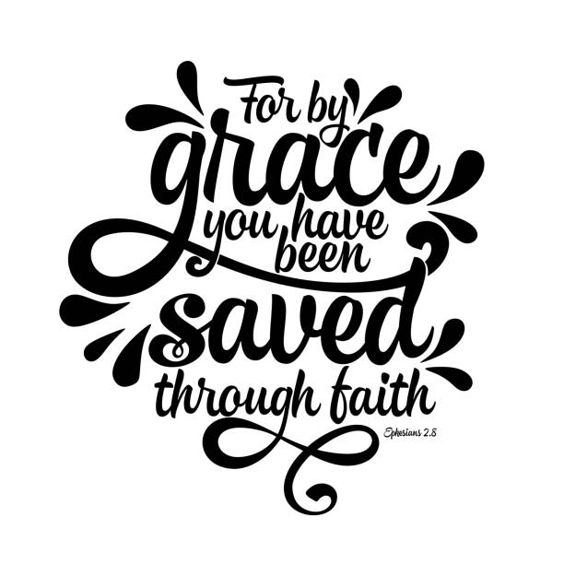
Thursday Worship
We continue to offer a Thursday Worship Service for those unable to attend on Sunday. Rev. Betty Wyatt serves as the Pastor for that service. She comes from St. Paul’s in Aniwa and is a former member of Calvary and remains an Associate Member. We were blessed to see Betty’s spiritual growth as a member of Calvary Lutheran Church, Betty attended Lay School and then Wartburg Seminary. Her ordination was held at Calvary. We thank her for willingness to help us during this time of transition.

Thursday Worship Service
6:00 PM

__________________________

Friendship Circle
Ladies we meet the third Tuesday of each month at 6:00 PM, usually around the table in the kitchen at Calvary. We have a short Bible Study (currently we are delving into Carlyn Rivadeneira’s Book called “Grit and Grace”) and then spend time sharing and caring about one another.

The current study is really written for young girls, but adult women from all over are using it for their studies. It is based on Heroic Women of the Bible.

As, Sarah Bessey said in the Foreword of the book: “We see women of God who kicked every stereotype to the side and followed God with grit and with grace. In this book you meet women who were preachers, women who were prophets, women who were leaders, women who were pastors, evangelists, teachers, and army commanders! You meet women who were brave and bold, women who were wily and clever, women who were fully alive, women who were flawed –just like us!—and yet said “yes!” to God.

We invite you to join us as we continue this study and continue our journey as Women of Grit and Grace.

New Member Sunday
January 12, 2020
We will be receiving new members during our Sunday Service January 12.
If you are interested in joining our church family please contact the church office.

