Calvary Lutheran Church ELCA

310 S. Superior St.

Antigo WI 54409

715/623-3102

Address Service Requested

**CALVARY CURRENTS**



October 2019

**Calvary Lutheran Church**

**310 S. Superior St.**

**Antigo, WI 54409**

**Church Phone 715/623-3102**

In case of emergency pastoral care: Rev. Betty Wyatt 715-219-8132 / Deacon Pam Werth 715-219-6363

Adm. Asst.: Lynda Eschmann Cell:715-216-0342 Home:715-623-7938

Custodian: Richard Tews 715/623-3522

**Your Church Council for 2019:**

Dan Young: President - 715-253-3938

Dale Waterhouse: Vice President - 715-623-3523

Joann Schmidt: Treasurer - 715-216-7106

Angie Close: 715-610-7118

Linda Grall: 715-219-3912

Julie Kubiaczyk: 715-627-4077

Craig Nelson: 715-623-4154

Edd Hill: 715-501-0418

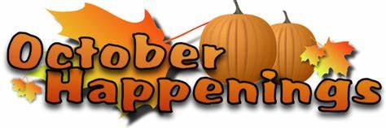

|  |  | | | | | [N](https://www.wincalendar.com/Holiday-Calendar/November-2019) |
| --- | --- | --- | --- | --- | --- | --- |
| **Sun** | **Mon** | **Tue** | **Wed** | **Thu** | **Fri** | **Sat** |
|  |  | 1 | 2  3:45 Confirmation Class  5:00 Calvary’s Kids | 3  6:00 PM Worship with  Holy Communion  (Deacon Pam Werth) | 4  Pick up date for LWR  Quilts and Kits | 5  Ship Date for LWR |
| 6  9:00 – 9:45 Lectionary  Text Study with Glen  Gildemesiter  10:00 AM Worship with  Holy Communion  (Pastor Jeff Martinson)  11:00 AM Council Mtg | 7  9:00 AM Quilting | 8 | 9  3:45 Confirmation Class  5:00 Calvary’s Kids | 10  6:00 PM Worship with  Holy Communion  (Deacon Pam Werth) | 11  “Here I AM” Retreat  Mount Tabor Center Menasha | 12  10:00 AM Grief Support  (Fellowship Hall) |
| 13  10:00 AM Worship with  Holy Communion  (Pastor Bruce Beyer)  Reception of New Member Benita Hupf  Donut Sunday | 14  9:00 AM Quilting | 15  Food Drop Off for Chili  Making for AVAIL  6:00 PM Friendship Circle | 16  3:45 Confirmation Class  5:00 Calvary’s Kids | 17  6:00 PM Worship with  Holy Communion  (Deacon Pam Werth)  Chili Making for AVAIL | 18  AVAIL – Chili Pick Up | 19  Kristy Bovre – use of  Fellowship Hall  (10 AM – 4PM) |
| 20  10:00 AM Worship  (Glen Gildemeister) | 21  9:00 AM Quilting | 22 | 23  3:45 Confirmation Class  5:00 Calvary’s Kids | 24  6:00 PM Worship with  Holy Communion  (Deacon Betty Wyatt) | 25 | 26 |
| 27  10:00 AM Worship with  Holy Communion  (Pastor Bruce Beyer)  REFORMATION SUNDAY WEAR RED | 28  9:00 AM Quilting  Theological | 29  5:30 PM Meeting for  Committee Chairs and helpers for  Calvary’s Holiday Bazaar  Conference | 30  3:45 Confirmation Class  5:00 Calvary’s Kids | 31  6:00 PM Worship with  Holy Communion  (Deacon Betty Wyatt) |  | |

**Council Person in Charge:** Angie Close

**Thursday Altar Guild:** Jan Young, Rachel Noskowiak, Karen Traut, Joann Schmidt

**Sunday Altar Guild Oct:** Connie Peterka

**Thursday Service Ushers & Greeters**: Loren & Wilma Lucia

**Sunday Ushers & Greeters Sunday Lectors Sunday Communion Assistants**

Oct 06 Tim Grall & Ted Clark Oct 06 Robin Gardner Oct 06 Connie Peterka

Oct 13 Dale Peterson & Bill Eschmann Oct 13 Kathy Stockhaus Oct 13 Robin Gardner

Oct 20 Randy & Karen Williams Oct 20 Dick Strasser Oct 20 No Communion

Oct 27 Jeff & Mary Lou Paulson Oct 27 Linda Grall Oct 20 Julie Kubiaczyk

A Note from Pastor Dean Marin

Dear Friends in Christ,

Marie and I were most happy to be with you at Calvary on Sept 1st. The time together brought back many wonderful memories from our time in ministry at Calvary. It was special to see many of the members from long ago as well as many new faces at worship. Calvary continues to provide the love of Christ at this time in history. Marie and I continue to pray for you and thank you for the special time we could be with you last week.

God Bless,

Dean and Marie Marin

*Pastor Marin served as pastor of Calvary from 1969 – 1972. He is now retired. He and his wife, Marie, live in Woodruff WI.*

*Marie provided special music in place of our Hymn of the Day. The hymn entitled “Reaching Out” was written in 1990 by her then 75 year old mother, Agnes L. Peterson, and was written in celebration of Immanuel Lutheran Church’s Centennial (located near Caston WI). It was a very special day. We thank Rev. Marin and Marie for sharing the day with us.*

_________________________________________________________________________________________

**Beginning the first Sunday in October:**

**Lectionary Bible Study, Coffee, and Homemade Bakery**

**in Fellowship Hall**

We are excited to announce that beginning Oct. 6 and continuing on the First Sunday of each month – prior to worship form 9:00 AM – 9:45 AM - Glen Gildemeister will hold a Bible Study at Calvary. The study will be based on the Lectionary (lessons) for that Sunday.

Glen was the Director of the Regional History Center at Northern Illinois University and the University Archivist. He presents an interesting and informative study and we are so pleased that he will be back with us to lead us in Bible Study.

*Besides – he makes wonderful baked goods! So come enjoy a cup of coffee, fresh bakery, fellowship and dig a little deeper into the lessons for that Sunday morning. It will enhance your worship experience! ______________________________________________________________________________________________*

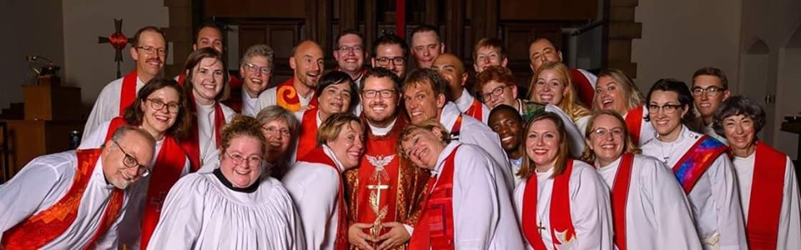

Timothy Schroeder was ordained on September 20, at University Lutheran Church of Hope in Minneapolis, MN. Tim has been called to serve as part-tme Associate Pastor at Peace Lutheran Church in Coon Rapids, MN. He will also serve in the Admissions Office at Luther Seminary, in Minneapolis.

Tim is the son of David and (the late) Cynthia Schroeder. The Schroeder Family joined Calvary in 1992, and have been faithful members ever since. We are proud of Pastor Tim. We know he will be a blessing to Peace Lutheran as he serves them with his many talents and great faith.

We extend our condolences to:

Members: Robin Gardner and Julie Zack and all their family members upon the death of their mother, Judith Wilton. Judy was a long time member of Calvary and faithful member of Calvary Quilters.

Members: Joseph and Stefanie Tatro & big sisters’ Ayla and Adalyn upon the death of their son and little brother Graham Tatro (1yr old).

Please continue to keep the family and friends of Judy and Graham in your thoughts and prayers.

If you would like to send your personal condolences and do not have an address please contact the

church office.

Dear Members of Calvary,

Writing you a short note to keep you informed on the exciting things happening at Calvary. We are moving forward on the multi-point parish plan. We are currently four churches in the process. There is also a committee that has been formed to draft a church profile. The profile will describe who we are as a congregation. This is an important step and one that we will all have the ability to have some input. Your awareness of and involvement in this process is crucial to the success of our congregation and its mission in Christ’s work of sharing the truth of the Gospel. When added to the other churches profiles, this will help us call a Pastor that shares our values and who will inspire us to share our faith with others.

Since last March we have had the pleasure of multiple Pastors sharing their ministries with us, giving us a unique opportunity to hear a variety of approaches to the Gospel message. Be sure to come to worship often so as not to miss out on this wonderful experience.

Calvary’s Kids and Confirmation Classes are ramping up for the school year so if you have children of that age or know someone who does, invite them to stop by the church office and be sure to sign-up. This is vitally important to the development and continuation of their faith as they grow older.

Hopefully you all had a blessed summer and are looking forward to strengthening your faith in Christ as fall approaches and we begin to prepare for Advent.

God Bless,

Your church Council

**TOWN HALL MEETINGS**

**A Town Hall Meeting was held on Thursday, September 26 and Sunday, September 29.**

**Dan and Angie updated the congregation on current happenings in the process of completing a Ministry Site Profile to submit to the Synod in order to fulfill our needs for new pastoral leadership.**

**In order to complete the profile, we want to make sure every member of Calvary has an opportunity to share their voice.**

**Surveys are available on the table in the narthex/next to the October Newsletter or contact the church office and we will make sure you receive one.**

**We ask that surveys be completed and returned by October 20, 2019.**

**Don’t forget to pick up your survey or call the office and we can mail it to you.**

**CALVARY’S HOLIDAY BAZAAR**

**Saturday, Nov 9, 2019 10:00 AM – 1:30 PM**

**Chairman: Janice Jorgensen 715-623-2749**

**THIS IS AN ALL MEMBER EVENT…your help is needed.** We are hoping every member (Men, Women and Students) will participate in some way. Maybe you can **make a craft, pour coffee, help in the kitchen or make a homemade pie or torte for the luncheon, help with set-up and clean-up, sell raffle tickets, purchase small gift items for the Secret Santa Gift Pile, or donate small gifts for the children’s duck pond (a work in process).**

.

** Registration numbers: Robin Gardner**

New to the bazaar the last two years was the registration sign-in desk. Attendees sign in with their name and contact information and receive their “sign-in number”. When you purchase a ticket for a raffle or drawing all you have to do was put your “sign-in number” on the ticket. It works so well, and saves so much time and energy.

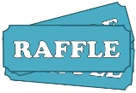

**Raffle Tickets:** **Julie Kubiaczyk**

***Sell tickets to your family and friends***. Great prizes! Tickets sell for $1.00 a piece or 6 for $5.00 – tickets will be available in the narthex, before and after services, and at the Bazaar. Please take extra tickets to sell to your friends and relatives.

.

**Secret Santa: Janice Jorgensen & Jenny**

***We accept new items (notions, lotions, note cards, candy, candles, toys and games, etc.*** – things that can be wrapped and added to our gift piles. We also accept monetary donations, gift cards or radio auction discounts to purchase items. ***Do you like to wrap?*** – Sign up and help on Wednesday, November 6, at 9:00 AM. Don’t forget to buy a chance to win an entire tote of secret gifts on the day of the

Bazaar.



**Crafts / Quilt Booth: Jan Diestler & Sandy Nieforth**

***Do you like to knit, sew or have a favorite craft or hobby that you would like to share***? Donate it to the Craft Booth, we suggest that you either price the items or tell us the cost. Sandy and Jan can always use help in the booth.



**Bucket Raffle: Benita Hupf, and Nicole & Chelsea Kubiaczyk**

***Donate a basket or a service for our Bucket Raffle Table***. Tickets are sold and dropped in the bucket for a chance to win the corresponding item. We always have a great response to this event. Please bring your baskets (etc.) into the

office early so we can make tags and know how much space we will need.

We love how creative people can be with this fun event.



**Kitchen: Pat Peterson and Linda Grall / Cashier: Kathy Stockhaus**

**Help in the kitchen on the day of the bazaar.** There are always dishes to wash, coffee to be made, pies to slice, and food to be served. Gail LeVeque is making chicken dumpling soup, the men are making Ski Hill BBQ, and Tim & Linda Grall are donating the pulled pork for sandwiches. We need your

homemade pies and tortes for this event. YUM!!

**Dining Room: Joann Schmidt & Connie Peterka**

***Servers are needed for the dining room.*** Serve the beverage, help people find a seat, make sure places are clean and properly reset when someone leaves. There are many things to do and many ways to help.



**Bakery Booth: Jean Guse, Bonnie Strasser and Joleen Davidson**

***Make a pie, bake a cake,*** ***bring your delicious cookies, brownies, breads, or candies.*** Your favorite homemade salsas, jellies or jams also go well. We will price the items for you.



**50/50 Raffle: Tina Chroge**

Purchase tickets to receive 50% of the 50/50 raffle sales.

ALL items can be dropped off ahead of time in the church office or brought to the church on Friday, Nov. 8, from 9:00 AM to 7:00 PM. Sign-up sheets will be posted on the kiosk in the narthex – any questions just give our chairman Janice Jorgensen a call (715-623-2749) or contact Lynda in the church office (715-623-3102) or (715-216-0342). **Become part of the fun! Get involved.**

The money raised goes to support the Women’s Group. They provided everything from our paper products to Confirmation Gowns and Children’s Bibles . . . they even help with heating bills, etc. when necessary.

Together we can make this another great event!



Oct. 29 at 5:30 PM Tuesday, Next meeting for Chairman and interested members to finalize plans

for the bazaar.

Nov. 6 at 9:00 AM Wednesday, Wrapping of Secret Santa Gifts (Quilting Room)

Nov. 8 at 9:00 AM Friday, Set Up for Bazaar and drop off your donations until 7:00 PM

Nov. 9 at 10:00 AM to 1:30 PM Come to the Bazaar – bring a friend!

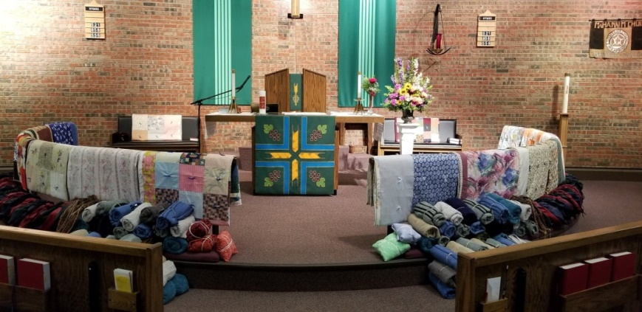



**OCTOBER - 2019**

01 – Tracy Hilger

Cathy Roth

05 – Matthew Gardner

Julie Nelson

09 – Bernice Andraschko

Bruce Brown

Gene Mackey

10 – Alexandria Forster

Caleb Schmidt

12 – Mathias Kemmer

13 – Montana Grabowsky

16 – Connie Rosio

David Schroeder

Rebecca Stockhaus

18 – Rev. Timothy Schroeder

Vickie Wagner

21 – Larry Poltrock

Richard Tews

24 – Blake Conant

Tom Krueger

25 – Tim Grall

26 – Shirley Mackey

27 – Tyler Poltrock

30 – Landon Nelson

Jesse Poltrock

31 – Darlene Bennett

Destiny Geiger

**Lutheran World Relief Drive**

**Thank you for another great year!**

**60 Mission Quilts**

**66 School Kits**

**94 Personal Care Kits**

**5 Fabric Kits**

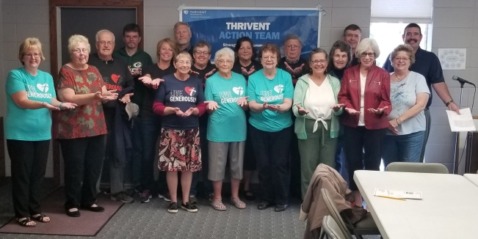

**“God’s Work. Our Hands. Sunday!”**

**Members of Calvary and St. John’s joined together**

**to make Fleece Blankets for the Langlade County Foster Care Program and to collect flags from area cemeteries.**

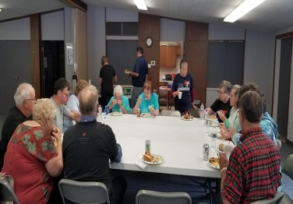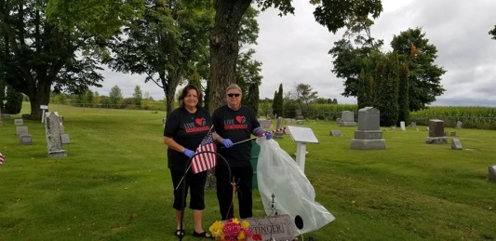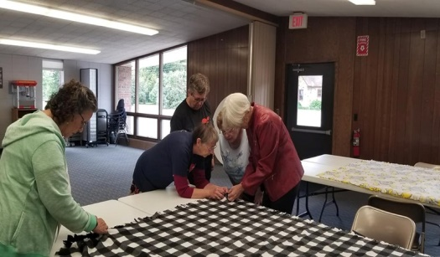

**________________________________________________________________________**

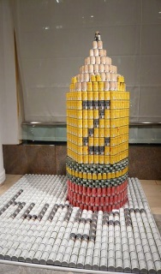**CALVARY AND ST. JOHN’S LUTHERAN JOIN TOGETHER TO ERASE HUNGER!**

**Thank you to everyone for your help with our 2019 CAN-structure for the Annual Thrivent Financial Can Hunger Event. Your donation of cans, financial support, and time spent in the construction is appreciated. We could not have done it without you!**

**Remember to vote: Starting September 30. Go on line to antigofoodpantry.com…click on EVENTS…select Thrivent Cans Hunger 2019 … follow voting instructions. You can vote once a day!**

**East Central Synod of Wisconsin**

**CONGREGATIONS IN TRANSITION**

**In Transition/Developing MSP**

Antigo, Calvary

Birnamwood, Trinity

Birnamwood, St John

Coloma, Prince of Peace (Rev. Joyce Heintz, interim)

Fond du Lac, Church of Our Saviour

Green Bay, Christ Community (Rev. John Sell, interim)

Green Bay, Incarnation (Rev. Ralph Hankermeyer)

Lessor, Our Savior’s

Merrill, Calvary

Mosinee, St John

Neenah, St. Paul (Rev. Amy Perron, interim)

New Holstein, Gloria Dei (Rev. Jim Liddle, interim supply)

Oconto, First American

Suring, Our Redeemer (Rev. Fred Mai, interim supply)

Sherwood, Christ the King (Rev. Roland Lindeman, interim)

Sturgeon Bay, BayView (Rev. Beth Macha, interim)

Wittenberg, Redeemer

**Receiving Names/Interviewing**

Berlin, Grace (Rev. Ted Johanson, interim)

Cicero, Immanuel (Rev. Vicki Jens Page, interim)

Fairwater, Zion (Rev.Amanda Nesvold, interim)

Green Bay, Peace –co-pastor

Kewaunee, Grace (Rev. Gary Stangland, interim)

Marion, St. John

New London, Trinity (Rev. Vicki Fink)

Poy Sippi, First (Rev. Ted Johanson, interim)

Valders, Faith (Rev. Jim Wilson)

Wausau, Saint Andrew –associate pastor

Wisconsin Rapids, Bethany – (Rev. Dennis Olson)

**Recommending Candidate for Call**

Oshkosh, All Saints (Rev. Dean Desilet)

**Accepted Call, Awaiting Installation**

Appleton, Zion (Rev. Catherine Burnette)

Green Bay, Calvary – associate pastor (Rev. Rufus Kudee)

Neenah, Our Savior’s (Rev Jon Strasman)

Oshkosh, First English – associate pastor (Rev. Jon Wills)

Seymour, Immanuel – senior pastor (Rev. Ty Stoneburner)

***(Just to let you know we are not in this alone ~ and to keep you informed of what is happening in our Synod.)***

**About the Evangelical Lutheran Church in America**:

The ELCA is one of the largest Christian denominations in the United States, with about 4 million members in nearly 10,000 congregations across the 50 states and in the Caribbean region. Known as the church of "God's work. Our hands," the ELCA emphasizes the saving grace of God through faith in Jesus Christ, unity among Christians and service in the world. The ELCA's roots are in the writings of the German church reformer, Martin Luther.