Announcements

Oct. 09 – 8:30 CLC Worship and Donut Sunday
CLC Meeting for Bazaar
10:30 SJL Worship
Oct. 10 – Can-structure pick up
6:30 CLC Jr. Woman’s Club in Fellowship Hall
Oct. 11 – 6:30 SJL Council Meeting
Oct. 12 – CLC Confirmation Class Family Meeting and Pizza Party
Oct. 13 – SJL Women’s Meeting
Oct. 15 – 9:00 – 12:00 SJL Fall Sale –
Oct. 16 – 8:30 CLC Worship w/communion
9:30 SJL Sunday School
10:30 SJL Worship w/communion,
Confirmation for Sawyer Kluck
Oct. 17 – 19 Vicar Jennifer at Theological Conference for ECSW
Oct. 23 – 8:30 CLC Worship
10:30 SJL Worship
Oct. 25 – CLC 10:30 Worship and Music Meeting
Oct. 26 – Community Soup Supper at Calvary 4:30 – 6:00 in
Fellowship Hall
Oct. 30 – 8:30 CLC Worship w/communion
9:30 SJL Sunday School
10:30 CLC Worship w/communion

ST. JOHN’S LUTHERAN
W17680 Church Rd. Birnamwood
Fall Sale – Sat. Oct. 15, 2022
9:00 – 12 Noon
Come one and All
Bake Sale, Craft Items, Vanilla, Greeting Cards,
Rada Knives, and SJL Cookbooks.
Please join us. We do offer Coffee and
Cookies as refreshments.
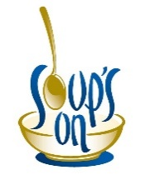
A Community Soup Supper will be offered the last Wednesday of each month starting October 26, form
4:30 – 6:00 p.m. at Calvary. The meals are free of charge, but donations are accepted. Menu for this month: “Zuppa” or “Chicken Noodle” Soups, Grilled Cheese Sandwiches and Dessert ala Surprise, along with coffee, milk, water, and lemonade. “Taste and see that the Lord is good! – Psalm 34:8
ALL ARE WELCOME

18th Sunday after Pentecost
October 9, 2022

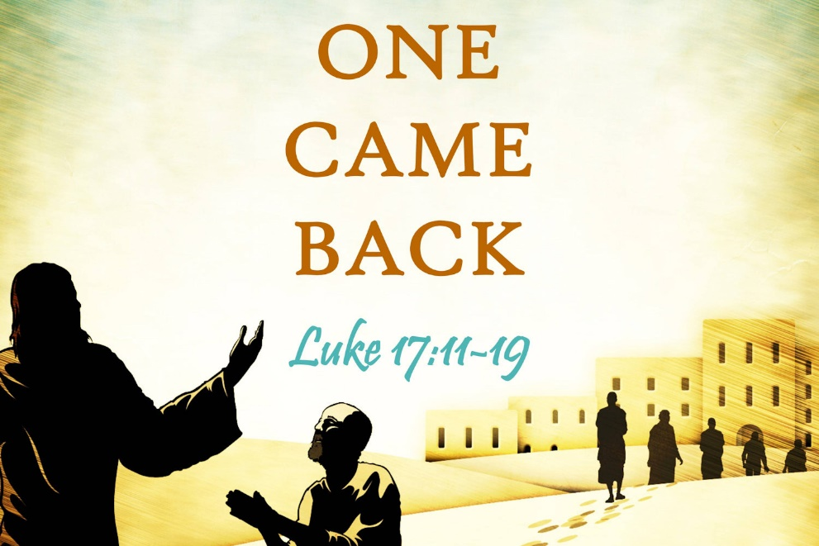

“Were not ten made clean? But the other nine, where are they? Was none of them found to return and give praise to God except this foreigner/?”

KINDRED LUTHERAN PARISH
Vicar Jennifer Sosinski – 715-219-5489
Email:vicarjennifer@outlook.com

Calvary Lutheran Church (8:30 a.m.)
310 S. Superior St. – Antigo WI 54409
Phone: 715-623-3102
Email: calvary.antigo@gmail.com
Pianist: Carol Schafer Lector: Alan Bahr
Song Leader: Peggy Benes

St. John’s Lutheran (10:30 a.m.)
W17680 Church Road – Birnamwood Wi 54414
St. John’s Phone 715/449-2098
Email: stjohnlutheranchurch54414@gmail.com
Pianist: Barb Nelson
18th Sunday after Pentecost – October 9, 2022
(*) indicates please stand as you are able

Prelude
Call to Worship
Welcome and announcements

GATHERING
Confession and Forgiveness back cover of hymnal
Hymn: “Joyful, Joyful We Adore Thee” #836
Greeting and Kyrie p.147
Canticle of Praise: “Glory to God in the Highest. . .” p.148
The Prayer of the Day (in unison see Celebrate insert)

WORD
Readings as found in the Celebrate Insert
First Reading: 2 Kings 5:1-3, 7-15c
R: The Word of the Lord All: Thanks be to God.

Responsive Psalm: Psalm 111
Begin with refrain and repeat after the bold R

Second Reading: 2 Timothy 2:8-15
R: The Word of the Lord All: Thanks be to God.

Gospel Acclamation (Please stand as you are able) p.151
or as follows:
“Al-le-lu-ia Lord, to whom shall we go? You have the words of eternal life. Al-le-lu-ia.”

The holy Gospel according to St. Luke 17:11-19
All: Glory to you, O Lord.
The Reading
Gospel of the Lord. All: Praise to you, O Christ.

Children’s Message
Sermon: Vicar Jennifer Sosinski

Hymn of the Day: “Baptized in Water” #456

*The Apostles’ Creed (inside back cover of hymnal)

*The Prayers of Intercession (Celebrate Insert)
Hear us, O God. Response: Your mercy is great.

The peace of the Lord be with you always.
C: and also with you

share the peace with one another

The Offering
CLC: Offertory Hymn: “All That We Have” found in the blue folder
SJL: as announced
The Offertory Prayer

The Lord’s Prayer (in unison) p.154

Please be seated for the Blessing, Sending Hymn, and Dismissal.

The Blessing
Sending Hymn: “Lord, Dismiss Us with Your Blessing” #545

(Candles are extinguished during last verse of hymn)

The Dismissal Response: Thanks be to God.
Postlude

Kindred Lutheran Parish Prayer List:
- (SJL) Randy Schmidt, Cindy O., Bob G., Eric DeHart, Michelle Buss, Kristie Corazalla, Ed Hilger, Danielle (Hebewald) Andrews, Andy Peterson.

- (CLC) Dave Tessmer, David Schroeder, Maverick Clark (infant), Theresa DeBroux, Nancy Klemp, Jenny Olson, Patty Koeppel, Merna Schuman, Tommy Erlandson, Jan Cunningham, Amy DeBroux.

- Prayers for members & friends serving in the military:
Greg, Tony, Joe, David, Kari and Isabel

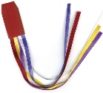
CALVARY
Thank you to Bill Eschmann for donating new Ribbon Hymnal Markers and to Julie Kubiaczyk for placing them in the hymnals.
Our current ones were missing ribbons, were frayed, and in some cases had disappeared. We ask that you please keep them nice and not braid them (which causes fraying) and make sure they remain in the hymnals. Thank you!

